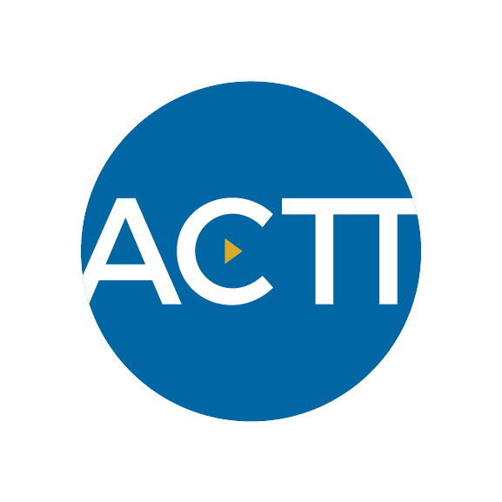  Enhanced Access |  | WHO?
 |  | Who could do it  (in scope) | Who has interest  experience/availability | RESPONSIBLE | CROSS-TRAIN
TASKS  TASKS | Example  QI and clinical tasks:
 | Review HQCA primary healthcare panel report
 | Talk to PCN about support for CII/CPAR implementation
 | Calculate for each physician: supply, demand & TNA
 | Monitor no-show rate
 | Review patient panel list and identify segments that may be served differently (e.g. group visits, CDM nurse)
 | Measure backlog
 | Review booking schedule and identify the number of appointment types
 | Create checklist for how to standardize exam rooms & equipment
 | Lead team huddles
 | Action eNotifications from CII/CPAR
 | Room patients
 | Record patient vitals
 | Schedule appointments
 | Perform medication reconciliation
 | Chart prep
 | Perform patient education
 | Administer injections

